Step1: Create an Azure Web API project with name “ManageAzureVMApi” using Azure API App template in Visual Studio 2015.

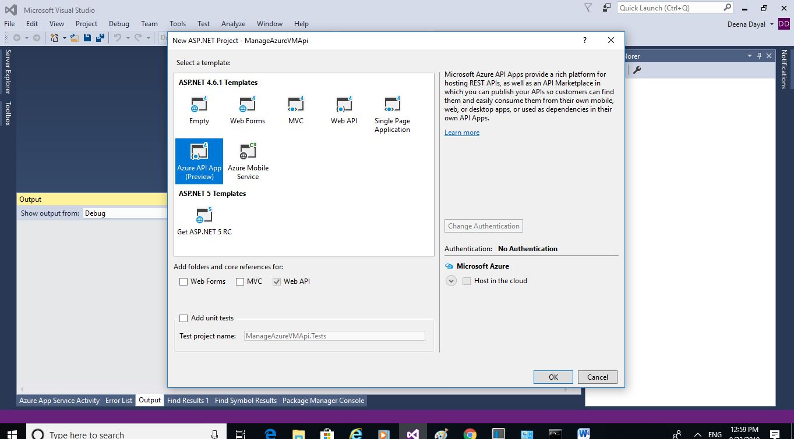

Step2: In order to create Azure Virtual Machine, we need to use Azure Resource Manager REST Api. Instead of directly accessing REST api using HttpClient we use a wrapper library called Fluent. For that click **Tools > Nuget Package Manager and then click Package Manager Console**. Execute the following command **Install-Package Microsoft.Azure.Management.Fluent**

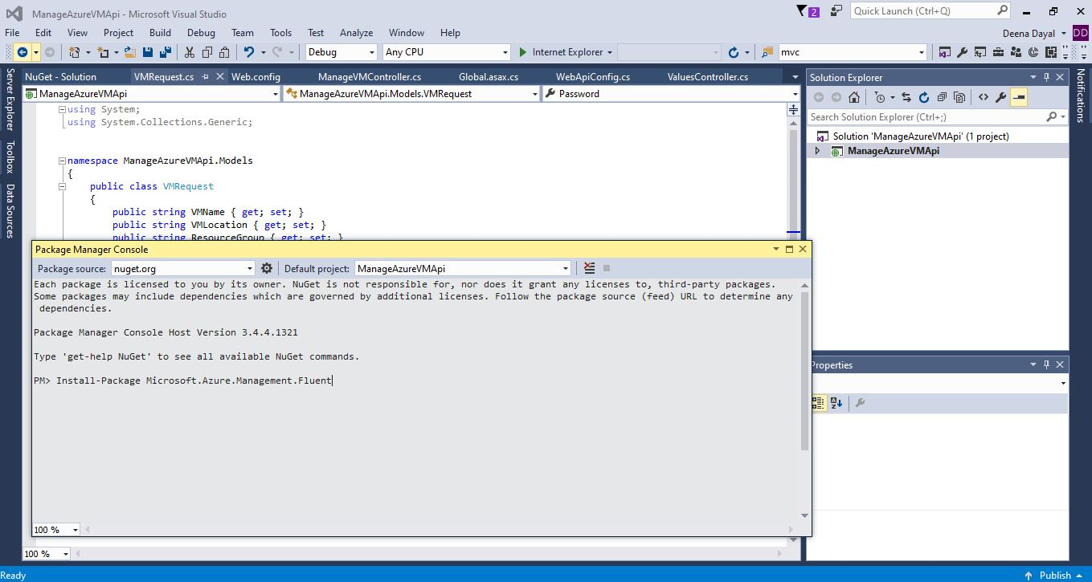

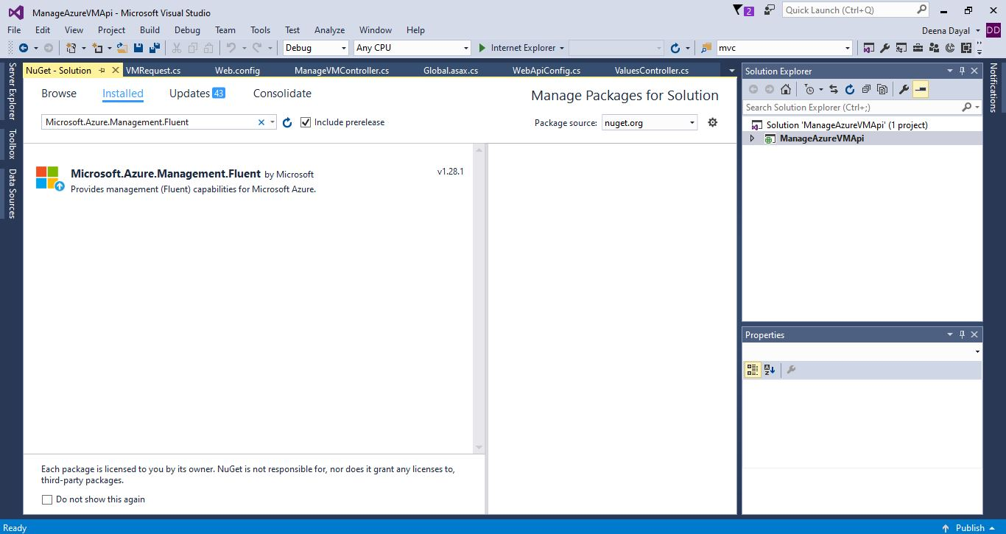

Step3: Enable Swagger UI in SwaggerConfig.cs by un-commenting the highlighted code.

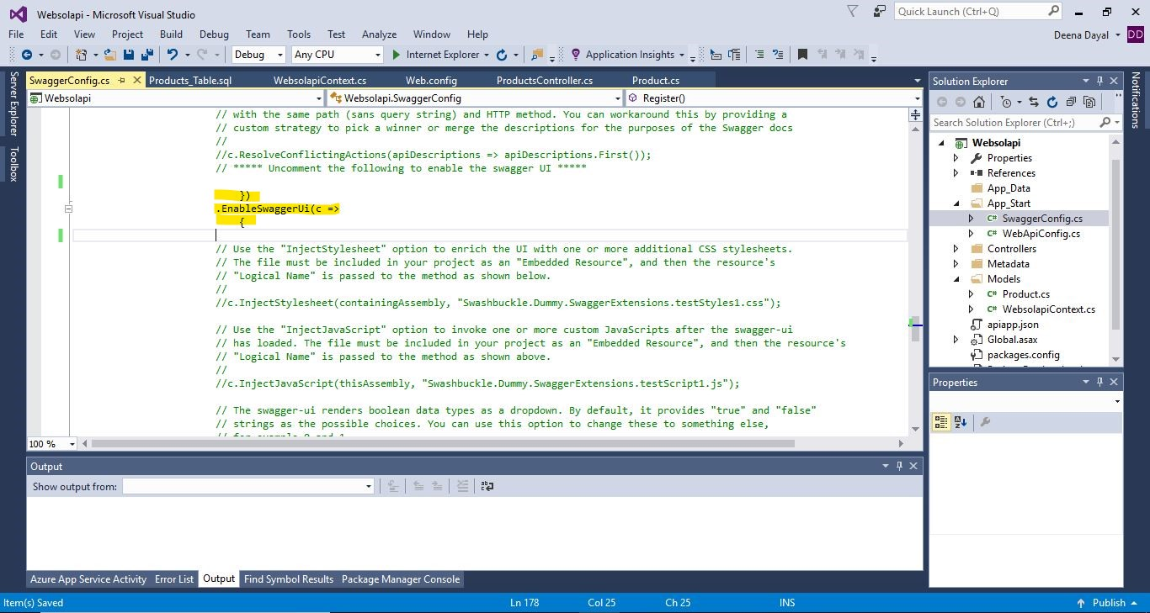

Step4: Enable CORS in WebApiConfig.cs to enable cross site api access.

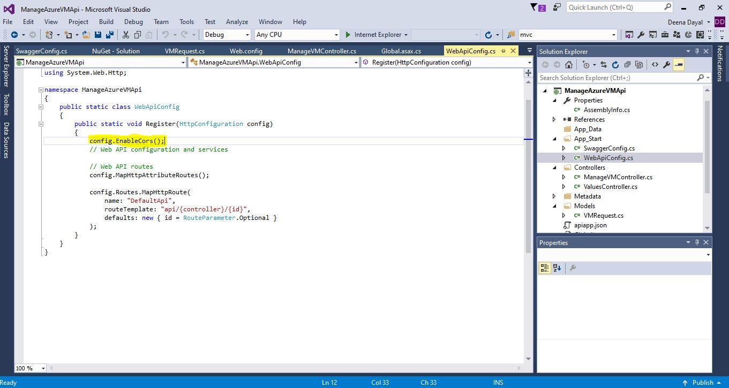

Step5: Add model class **VMRequest** with properties for VM creation and implement POST action method with parameter **VMRequest** in controller class **ManageVMController.**

Step6: Build & verify the application using Swagger UI

